March 2018 Newsletter
Sunday Services
Services 11 a.m. All Welcome
04 March Jef Jones (Lay Leader, BUC)
Pianist, Peter Mansfield
11 March Rev Maria Curtis (Horsham)
Pianist, Pamela Nickels
18 March Jef Jones (Lay Leader) - Equinox Service
Pianist, Kathy Pitt
25 March John Naish (BUC Member)
Pianist, Joe Ward
Quiet Reflection and Candle Lighting
Thursday 8 March 7 - 8pm
Please note that due to scaffolding at the front of the church there will no parking from 19th March until further notice.

Welcome from Jef
Welcome to our Newsletter for March 2018 which promises to be an exciting and busy month. I'm very much looking forward to our play, The Prince and The Pillars, written for the church by Janet Sate and produced by our member Joanne Howarth. Do come along to this imaginative re-telling of the founding of our church. There are performances from the 2nd to the 4th of March. On March 11th our good friends at the Interfaith Contact Group are holding their Annual Meeting at Friends Meeting House with what promises to be a fascinating discussion about angels. Then on March 16th, Derek McAuley, Chief Officer of the Unitarian General Assembly, will be giving our first Heritage Lecture 'Unitarian Women Who Made A Difference'. Finally on Sunday 18th March you are warmly invited to a potluck lunch in the hall after the Equinox Service. We're planning to do this after each Solstice or Equinox service. The purpose is simple; to sit down and share a meal together! Please bring food to share as you are able. Everyone is welcome.
Jef Jones, Lay Pastor
The Prince and the Pillars
To keep up-to-date with all that is happening at Brighton Unitarian follow us on:
Twitter: @BrightUnitarian
Facebook: https://www.facebook.com/BrightonUnitarian/
Share images of your experiences in our beautiful building using the following hashtags. #bucpeople #brightonunitarians

Quiet Reflective Circle
Thursday 8th March 7 - 8 pm
On the second Thursday of each month we gather for candle lighting and quiet reflection. This starts at 7pm and lasts no longer than an hour. There will be readings, time for candle- lighting, stillness and a few simple closing words.
If you’ve been having a busy week, and could do with some stillness, do come along. If you’re looking for a time and place to reconnect with your spirit, do come along. If you’d like to sit quietly in a sacred place, please do come along. All are welcome!

From the Lay Leader
I was eating with some friends recently and I announced with a degree of pride that I had given up Lent entirely for sugar. The truth is I have a sweet tooth and my slip of the tongue revealed some ambivalence (to say the least!) about giving up sugar altogether.
Lent is a time of giving things up in order to make time and space in the soul. But for what exactly? In her book of poems for Lent and Easter The Heart's Time, Janet Morley says of modern spirituality that it has 'a certain voluntariness and soft focus' in contrast with the passion and rigour of early Christians. Giving up sugar is hardly a rigorous sacrifice for me but it is making me think and feel differently about the time of year and what it means to me. I'm finding there is more space in me for gratitude, and I'm keenly aware of the many blessings in my life. 'Gratitude' is not quite the right word: what I'm feeling is a heartfelt appreciation for being alive, and for the twists and turns in my life that have brought me to my relationship with God. I'm feeling especially thankful for having grown up by the sea, and for living in a city by the sea. I've been thinking of the divine itself as oceanic, as a mysterious and untamed divine principle, sometimes serene and sometimes tempestuous. I am energised by the raging power of a good sea storm, and comforted by a still and calm sea. These things have brought a depth and flavour to my life for which I am thankful.
Giving up sugar has also made me think more keenly of the bitter things of life, and how they call for my compassion and engagement. I don't just mean the sour, global realities of violence, poverty and pollution but the everyday challenges of ageing, illness and bereavement. Being alive is a grace, a most straightforward gift, but feeling passionately thankful is perhaps only the beginning of a spiritual life. Striving to act with compassion and working for a fairer world are for me the most meaningful ways of giving thanks. I've also been reading a blog about Lent which expressed this very simply in three sentences: Go Deeper. Love Harder. See Beauty.

Parking
Please note that due to scaffolding at the front of the church there will be no parking from 19th March until further notice.

After the Service on March 4th
As we will be re-arranging the church and hall for performances of The Prince and The Pillars there will be no tea and coffee after the service on Sunday March 4th. If you’re available to help us move chairs out of the church that would be very helpful!

Equinox Service and Potluck Lunch 18th March
As always you are invited to contribute to our Equinox Service. If you have a reading or a few thoughts to share about the meaning of the Spring Equinox in your life you are welcome to contribute to the service in this way. After the service we will be holding a potluck lunch in the hall. All are welcome and please do bring food to share- it doesn’t need to be posh!

From our Treasurer, Phillida Simpson
Exciting news is that building work is to start this month. This is to carry out “Repair and Restoration of the Classical Portico”. Scaffolding will begin to go up on March 19th, and from then on access to the building will be via the South and North passages. The work is scheduled to last for 7 months. This work is essential: the church has been placed on the Historic England’s “At Risk Register” owing to the state of the pediment, the columns and the steps.
As you probably know by now the work is being partially funded (53% of the cost) by a grant from the Heritage Lottery Fund. But it is up to us to provide the rest of the cost. Our share will be in the region of £100,000. That we are able to do this is due in large part to a legacy which was left to the Worthing Unitarians nearly 20 years ago. When that fellowship was closed the investment was transferred to Brighton Unitarian Church. As well as that money we shall be using our own Building Appeal Fund money which has been steadily built up over the last few years by the efforts of the wonderfully hardworking Fundraising team, headed by Fanny Tulley. The general church finances have remained in good shape due in large part to the sterling work of our administrator, Marion Bance. She has managed the lettings of the church and the hall so that there are very few days in which we do not receive fees from regular and from occasional hirings.
Having secured the HLF grant we have made further applications for funds from a number of Trust funds, including several Unitarian trusts, all of which were established by the generosity of past generations of Unitarians. With help from some of these we may avoid having to draw too much from our own funds. We will then have to look to the future maintenance of our church building.

From Our Membership Secretary, Caroline Drijver
Following Jef’s service on membership (on 4th February) where I said a few words about this, I thought it might be useful to write a few words for those of you who weren’t there.
Our Brighton Unitarian Church constitution says that-
a) “Membership shall be open to any person, aged 18 or over, who is in sympathy with this Society's objects, completes and signs the membership form and pays the minimum annual contribution which shall exceed the Quota payments to the General Assembly.”
In practice, our church usually suggests that people who wish to become a member should have been attending fairly regularly for about six months. This allows the person interested in becoming a member time to get to know the ethos of the church, and also for the church committee to get to know the person a bit.
With regard to financial contributions, these are collected through the collection in the usual way, although some people prefer to use a standing order. Our church does not ask for a specific contribution, it is left up to the individual to decide. If you do become a member then you can attend the Annual General Meeting (usually in December) where you will have access to the Treasurer’s report. In this report you can see a breakdown of the Church’s costs and you can also see how much the congregation has contributed towards this. Every now and then we might get a little reminder from the committee of what the monthly individual contributions should be if it were calculated evenly between members, but this is not a compulsory amount.
b) “New members shall be agreed by the Committee”.
Please approach Jef, myself or any committee member if you would like to become a member.
c) “No doctrinal or creedal tests shall be imposed on or required from any Minister/Lay Leader or member of the Society”.
Thank goodness.
Although it may seem a little formal to have to go through a procedure to become a member, I believe it reduces the opportunity for cliques to form. You don’t get to be a part of the church by being chummy with people (although that may happen too), there is a way to become involved even if you are not naturally outgoing or you do not know people in the church (which can easily happen if you don’t want to or don’t have the opportunity to stay for socialising after the service).
Of course both members and non-members are equally welcome, but if you would like to take that a step further you can join as a member.
For me, being a member has meant that at times, and there have been and continue to be many, when I have attended more leanly, I know that I am still a part of this church and it is still a part of me. I like the feeling of this.
On a practical level, being a member means that you can attend and vote in the AGM and after a while, if you are interested, you can consider joining the committee.
So please, if you are interested, come and talk to Jef, myself or a member of the committee to talk more about

Safeguarding at Brighton Unitarian Church
Brighton Unitarian Church takes safety and safeguarding seriously. If you have any concerns for yourself or if you are concerned about another person please contact our safeguarding officer without delay.
Our safeguarding officer is Ann Woodhead. You can contact Ann through the Church office by calling 01273 696022 or email buc@brightonunitarian.org.uk
We have a safeguarding policy on file and you can request a copy of this.

March
Friday 2nd: Sussex Guitar Quartet play works by M. Praetorius, G. P. Telemann, L. Boccherini, A. Marcello, M.D. Pujol and Leo Brower
Friday 9th: Pianist Ambrose Page presents a programme of ‘Fantasies & Caprices’, featuring works by J S Bach, Haydn, Hummel and Granados.
Friday 16th: Concert Pianist Antonio Oyarzabel will present his debut CD ‘The Inner Child’ with music by Schumann, Debussy, Ravel and Mompou.
Friday 23rd: Duo Brikcius, 2 Cellists, 2 Siblings. Anna Brikciusová and František Brikcius performing works by Jacques Offenbach, Gideon Klein, Irena Kosíková and Leoš Janáček.
Friday 30th: Uproar at lunchtime: A selection of operatic arias ranging in mood from flirtation to the edge of madness, from Ireland's own star soprano and Glyndebourne chorister Deirdre McCabe, with Joe Ward on piano.
Doors and coffee from 12 noon.
Concert 12.30 – 1.15 p.m.
Tickets £3.50 on the door.

BUC Fundraising
The Curry Quiz Night raised £328.50 for BUC's building appeal fund. Thank you Kathy, Ann and Fanny for a very jolly evening.
Christine has made a selection of upcycled Easter cards which are for sale in the church.

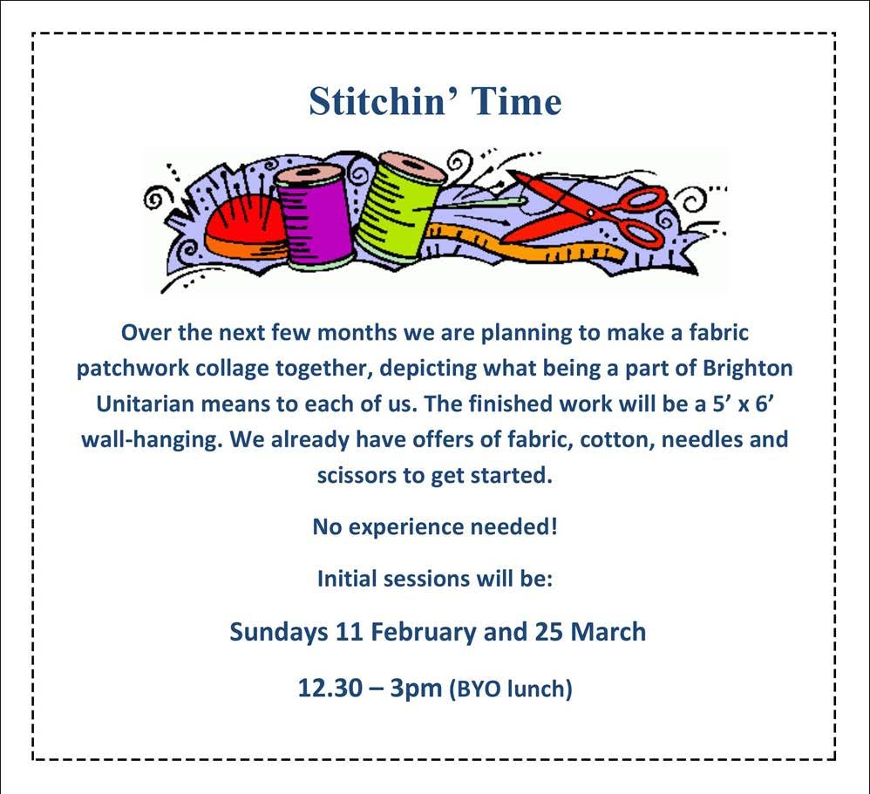
Dates for Your Diary
Heritage Lectures ​
The Heritage Lottery Fund has acknowledged the importance of our building as an integral parts of the City's Regency streetscape and is helping to fund the restoration of our classic facade and portico. As part of the project we will be raising awareness of the heritage of the building and is history, including a series of free lectures:
Friday 16th March, 6 p.m. - Derek McAuley,“Unitarian Women Who Made a Difference”.
Saturday 7th April, 2 p.m. - Dr Geoffrey Mead, “History of Brighton Unitarian and the Cultural District of Brighton”.
Saturday 21st April, 2 p.m. - Dr Sue Berry – “Amon and Amon Henry Wilds – architects and builders of places of worship and other buildings in Brighton”.
After the lectures there will be a Q&A session, an opportunity to meet the historians, tea and cake.

For more information about events taking place in the church please visit our website www.brightonunitarian.org.uk

